**THE FINALE**

**Task:**

You are steps away from capturing the noxious Kory!!! Your only job left now is to cut him off. Knowing that your car is running in a straigt line from point 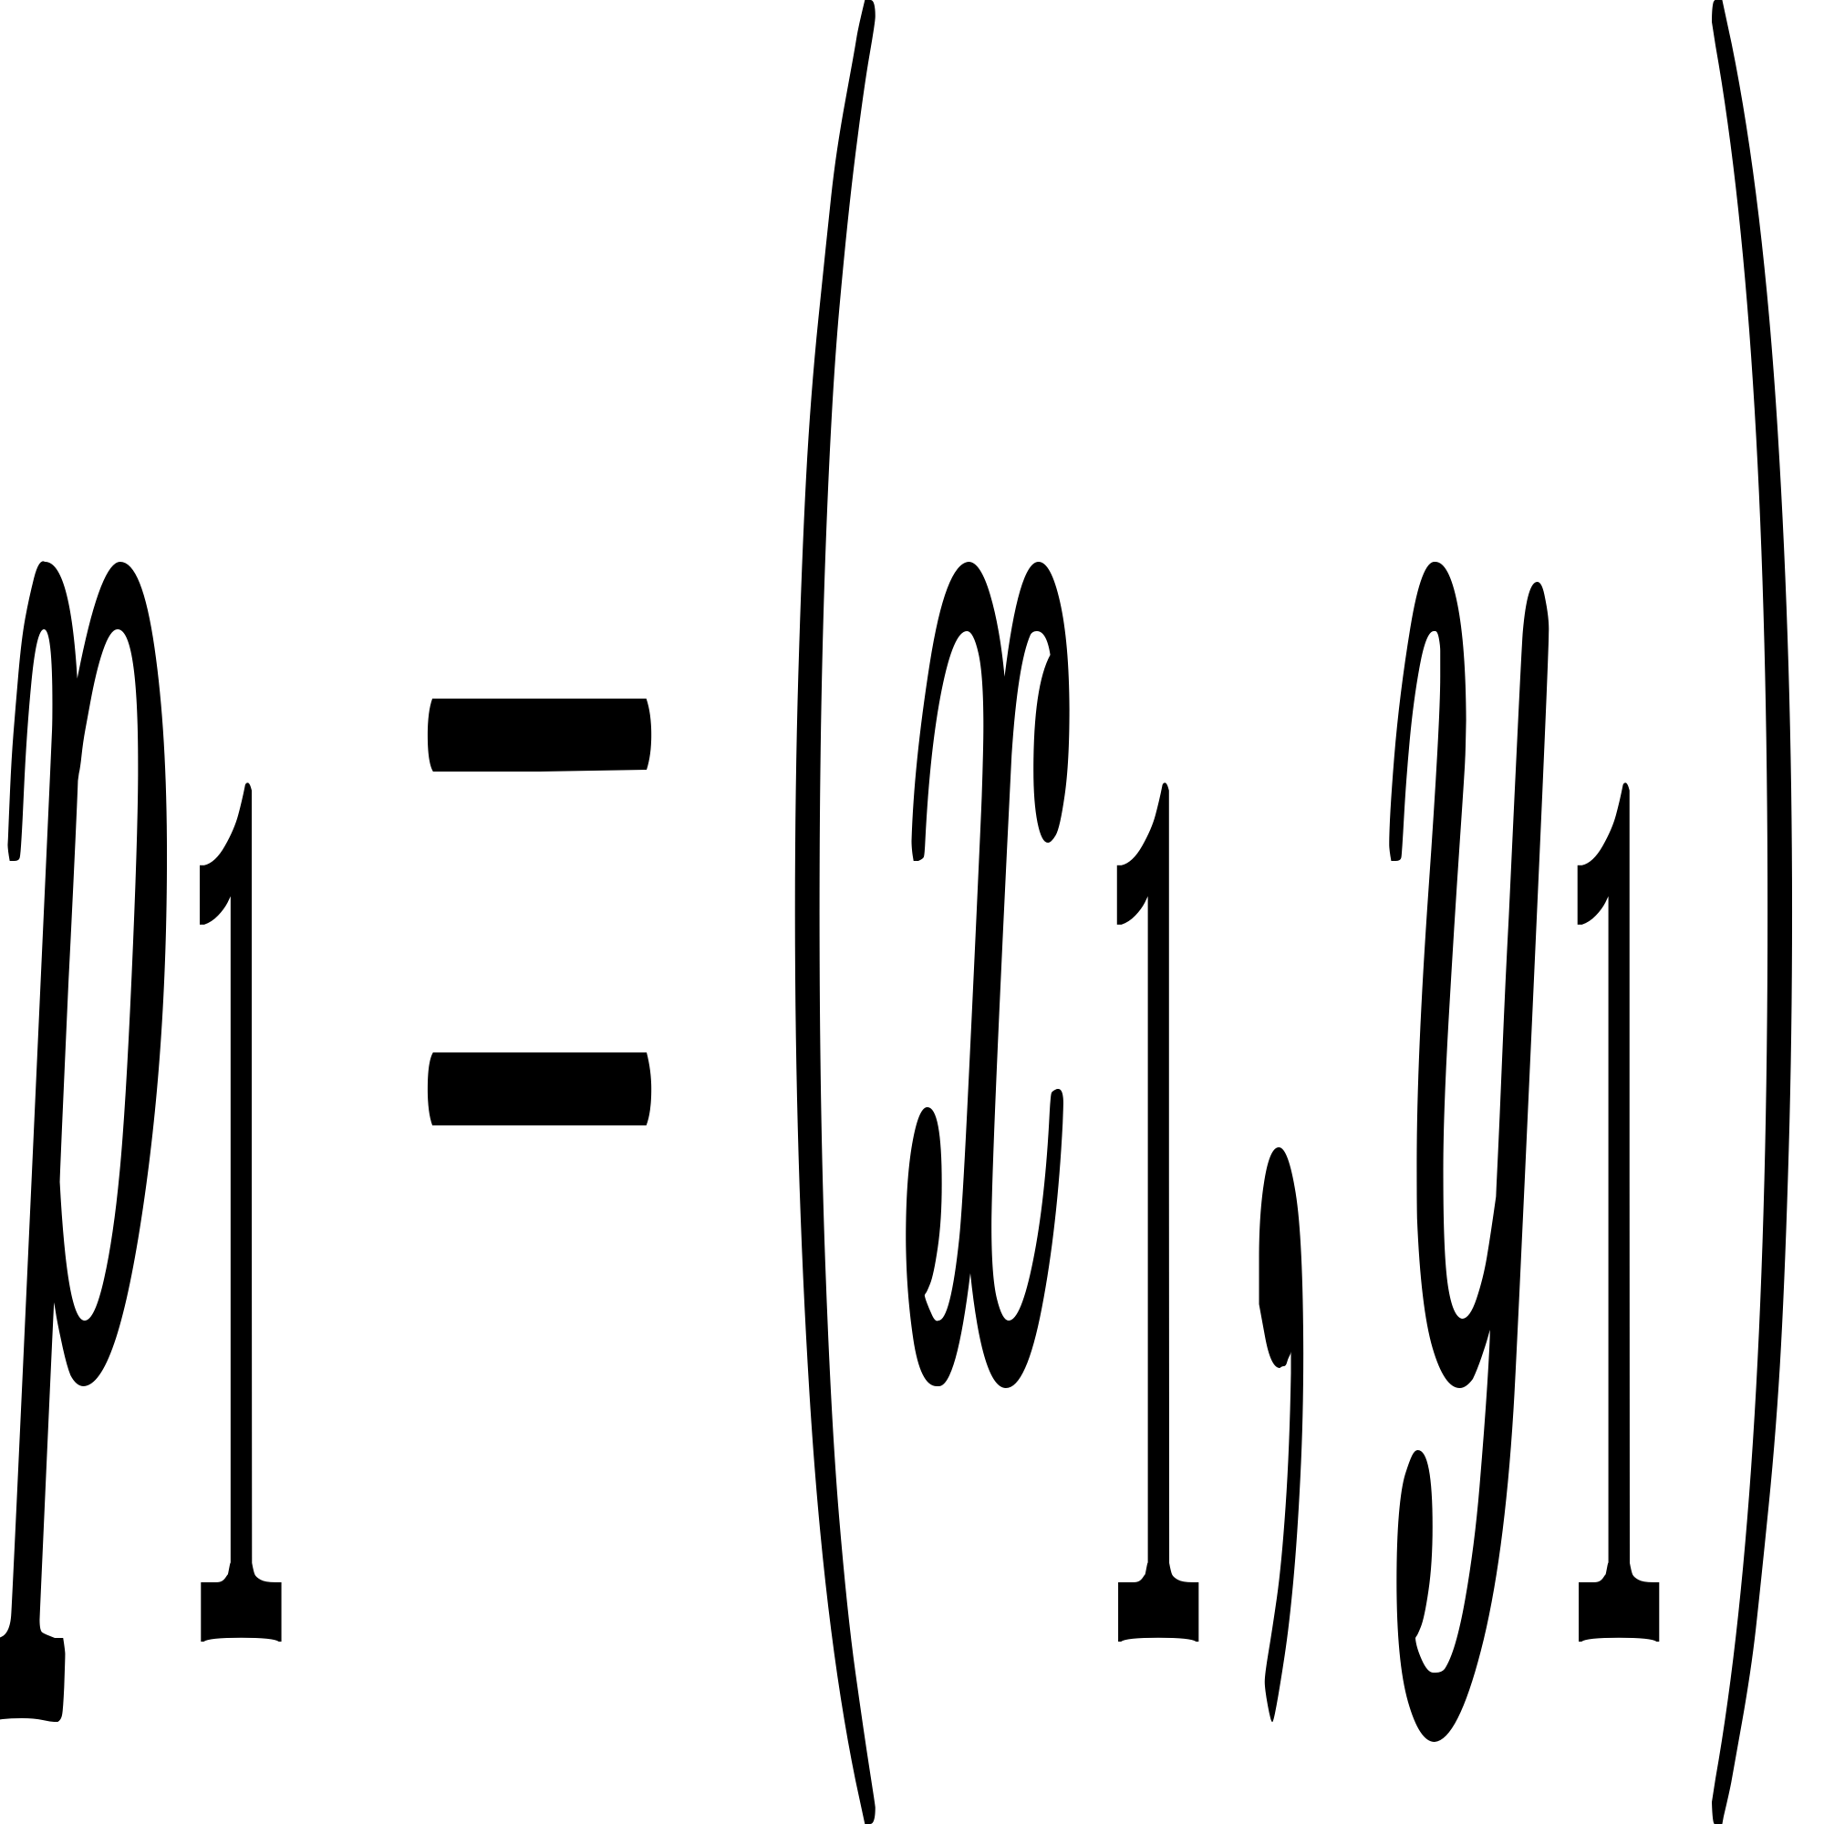 to C:/Users/Kory/AppData/Local/Temp/wps.KAxQaswps and Kory is on point C:/Users/Kory/AppData/Local/Temp/wps.gLRxhhwps.

Your task is to determine whether Kory is on the left side or the right side of your car or did you already ran over him.

**Input:**

The first line of input contains  C:/Users/Kory/AppData/Local/Temp/wps.HkyuDvwps. Each of the remaining lines describe two line segments with six integers C:/Users/Kory/AppData/Local/Temp/wps.yrmTaawps. The first line segment goes through 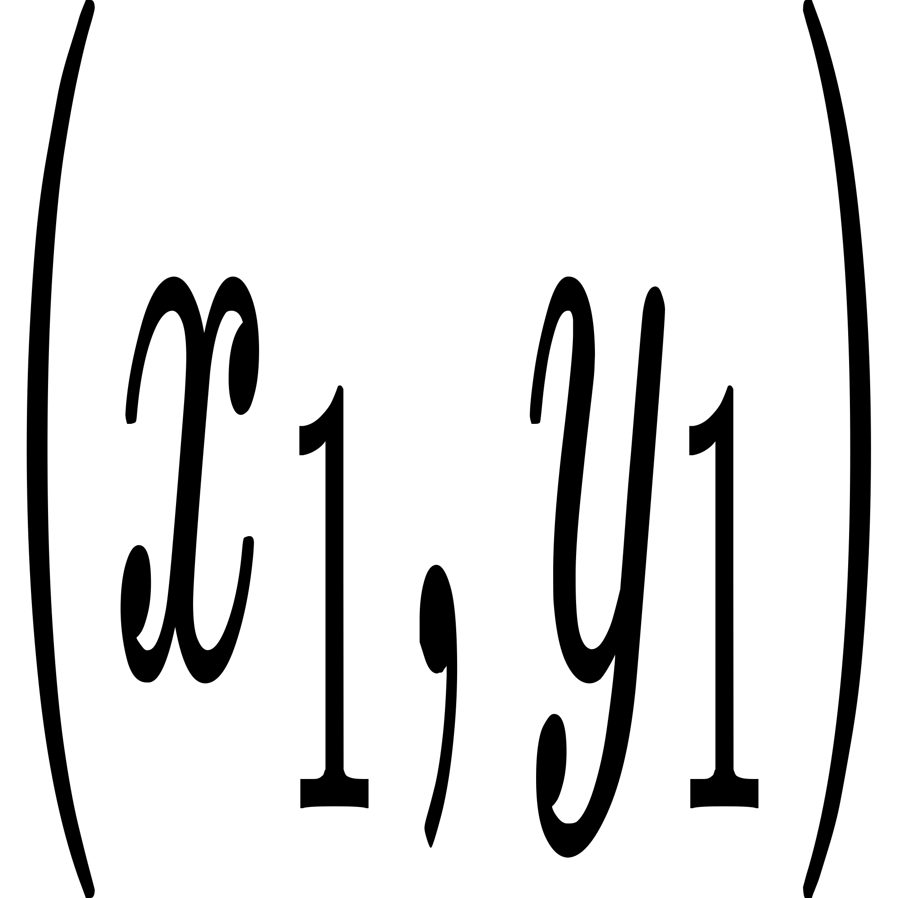and C:/Users/Kory/AppData/Local/Temp/wps.BTIzbuwps, the second line segment goes through C:/Users/Kory/AppData/Local/Temp/wps.ywSZZtwpsand C:/Users/Kory/AppData/Local/Temp/wps.hiZvVewps.

The first input line has an integer  C:/Users/Kory/AppData/Local/Temp/wps.HkyuDvwps: the number of tests.

After this, there are  lines that describe the tests. Each line has six integers: C:/Users/Kory/AppData/Local/Temp/wps.JNpmjfwps and wps.

**Output:**

For each test, print "LEFT", "RIGHT" or "TOUCH".

**Sample**

|  |  |
| --- | --- |
| Input | Output |
| 3  1 1 5 3 2 3  1 1 5 3 4 1  1 1 5 3 3 2 | LEFT  RIGHT  TOUCH |